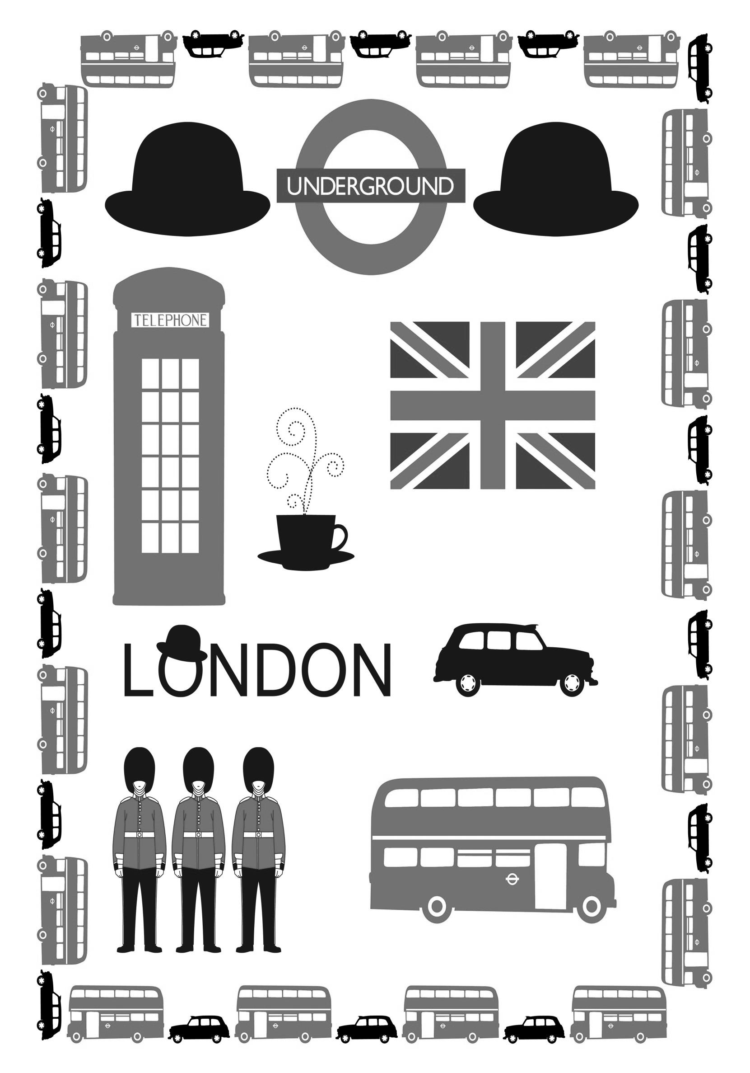

PHOTORECIT

Votre mission, après les vacances de février, que vous partiez à Londres ou pas, sera de créer un photorécit de votre voyage réel ou via Internet.
C’est un récit contenant des photos et des commentaires sur :
- des lieux
- des personnes
- des moyens de transport
- des plats
- des activités
- la météo
Il vous faut donc profiter de cette semaine du 07 au 10 février 2017 (et de vos vacances) pour faire ou rechercher des photos qui vous permettront de construire votre photorécit dès la rentrée du 27 février 2017.
Ces photos peuvent venir d’Internet ou bien avoir été prises par un appareil numérique. Vous devrez les mettre sur une clef USB afin de les enregistrer dans un dossier personnel en salle informatique.
Vous devrez également choisir une chanson en langue anglaise ne contenant pas de vulgarité pour accompagner votre photorécit.

HARROW SCHOOL
Si vous êtes en France cliquez sur http://www.harrowschool.org.uk/ pour essayer de répondre aux questions.
A full-boarding school for boys aged 13 to 18
Harrow School was founded in under a Royal Charter granted by Queen
It is located in northwest London.
The influence of Harrow's most distinguished alumni remains significant. The successes of these Old Harrovians, and those of many others, are the true test of a Harrow education.
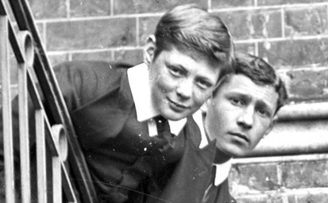
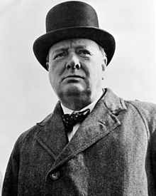

Winston Churchill

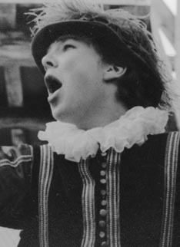
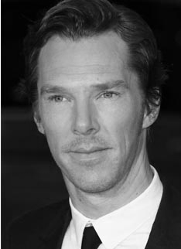

Benedict Cumberbatch

What are those 2 men famous for?
__________________________________________________________________________________________________________________________________________________________________________________________________________________________________________________________________________________________________________________________________________________________________________________________________________________________________________________________________________________________________________________________________________

MY FIRST DAY WITH MY HOST FAMILY
Si vous êtes en France, ces questions seront à poser à vos camarades à leur retour ; si vous êtes à Londres, il faut y répondre en anglais.
- What time did you go to bed on Tuesday 7th January 2017?
…………………………………………………………………………………………………………………………………………………………………………………..
- What time did you get up on Wednesday 8th January 2017?
…………………………………………………………………………………………………………………………………………………………………………………..
- What time did you have breakfast?
…………………………………………………………………………………………………………………………………………………………………………………..
- What did you have for breakfast?
□ tea □ coffee □ hot chocolate □ cold milk □ orange juice □ fruit juice
□ bread □ cereals □ bacon and eggs □ toast □ butter □ jam
□ beans □ biscuits □ hot tomatoes □ fresh fruits
I had : …………………………………………………………………………………………………………………………………………………………………………………..
…………………………………………………………………………………………………………………………………………………………………………………..
…………………………………………………………………………………………………………………………………………………………………………………..
- What did you have in your packed lunch?
□ sandwiches □ crisps □ chocolate bars □ a fruit juice □ a fizzy drink
□ a fruit □ sweets □ cucumbers □ ham □ cheese
□ chicken □ water
I had: ……………………………………………………………………………………………………………………………………………………………………………
…………………………………………………………………………………………………………………………………………………………………………………..
…………………………………………………………………………………………………………………………………………………………………………………..
- Where did you eat?
…………………………………………………………………………………………………………………………………………………………………………………..
…………………………………………………………………………………………………………………………………………………………………………………..

MY HOST FAMILY
Father’s first name……………………………………………….. Mother’s first name……………………………………………………………….
Have they got any children? (names and ages)
……………………………………………………………………………………………………………………………………………………………………………………………………………………………………………………………………………………………………………………………………………………………………………………………………………………………………………………………………………………………………………………………………………………………………………………………………………………………………………………………………………………………………………………………………………………
Have they got any pets? (names and ages)
……………………………………………………………………………………………………………………………………………………………………………………………………………………………………………………………………………………………………………………………………………………………………………………………………………………………………………………………………………………………………………………………………………………………………………………………………………………………………………………………………………………………………………………………………………………
What’s their address?
……………………………………………………………………………………………………………………………………………………………………………………………………………………………………………………………………………………………………………………………………………………………………………………………………………………………………………………………………………………………………………………………………………………………..

A FEW EXPRESSIONS
En arrivant: lorsque l’on vous présentera à votre famille hôtesse :
“Pleased to meet you! Glad to meet you!”
Si on vous offre de porter votre valise répondez poliment « Thank you, it’s kind of you. »
N’oubliez pas de dire: “good morning” ou “good evening” ou “hello”! Et le soir “sorry, I feel tired, I’m going to bed, good night…”
Si vous n’avez pas compris, ne dîtes pas « what ?» mais plutôt « Can you repeat slowly, please ? »
N’hésitez pas à proposer votre aide « Can I help you? » ou bien “Can I give you a hand?”
Remerciez quand on vous souhaitera “have a good time!” ou “enjoy yourself!”
Dans la maison: Can you show me the bathroom, please?
Can you show me the toilet/ the loo, please?
Les chasses d’eau anglaise peuvent être capricieuses, demandez de l’aide en disant “I can’t flush the toilet” ou “ I can’t work the flush”. Ne laissez aucune trace de votre passage, les familles ne sont pas là pour nettoyer derrière vous. Vous n’êtes pas seul dans la maison, demandez quand vous pouvez utiliser la salle de bain :
« When can I use the bathroom, please? “ ou “When can I have a shower?”
En quittant votre famille, n’omettez pas de les remercier : « I have enjoyed my stay », « it was a pleasure meeting you ! »
A table: Si on vous passe le plat, on vous dira “help yourself” pour que vous vous serviez. Goutez de tout, sans préjugés, la cuisine anglaise n’est pas aussi qu’on le dit.
Dans la rue :
Si vous êtes perdu ou pas sûr de votre chemin dites : « Can you help me please ? » « Could you tell me the way to… », soyez très prudent en traversant, on roule à gauche en Angleterre et nous, les français, n’avons pas toujours le réflexe de regarder du bon côté de la route avant de traverser !
Dans les magasins :
Attention ! Shoplifters will be prosecuted!= Les voleurs seront poursuivis en justice. De plus un touriste mineur devra rentrer directement dans son pays d’origine et à ses frais.
Vous voulez savoir combien coûte un article alors dites « How much is this please ? » ou « how much does it cost ? ». Si vous souhaitez essayer un vêtement « May I try it on ? »

SHAKESPEARE’S GLOBE
- Which footbridge can we cross to get from St Paul’s to the Globe?
- What’s the name of the river next to the Globe?
- Is this theatre the original Globe or is it a reconstruction?
- When exactly was the original theatre destroyed?
- Why were there so many windows? (wind holes)
- What’s the English for “une pièce de théatre”?
- What’s “un dramaturge” in English?
- Where do actors stand to be visible from the audience?
- Were plays reserved to an elite in Shakespeare’s time?
- Why did all theatres in London close for one year in 1594?
- Were women allowed to go on stage at Shakespeare’s time?
- Was Shakespeare born in London?
- In which century did he live?
- Who was the Queen at Shakespeare’s time?
- In which famous play does the eponymous character declare “To be or not to be”?
- Which other famous play tells the story of an impossible love?

Tool box
16th century/a play/a playwright/a reconstruction/Elizabeth Ist/in 1614/Hamlet/No, all social classes would go/No, in Stratford-Upon-Avon/ on a stage/ River Thames/Romeo and Juliet/The bad smells/The Millennium Bridge/the Plague/No, it was forbidden for women to go on stage.

THE NATIONAL GALLERY
Si vous êtes au collège, allez à http://www.nationalgallery.org.uk/visiting/virtualtour/#/room-34-B/
Parmi tous les tableaux de la salle 34, choisissez un tableau qui vous plaît beaucoup ou un que vous n’aimez pas du tout et présentez-le (nom du tableau, de l’artiste peintre et date de réalisation). Décrivez-le brièvement en anglais (comparez-le avec un autre par exemple) et faites un croquis afin de nous aider à le reconnaitre.
___________________________________________________________________________________________________________________________________________________________________________________________________________________________________________________________________________________________________________________________________________________________________________________________________________________________________________________________________________________________________________________________________________________________________________________________________________________________________________________________________________________________________________________________________________________________________________________________________________________________________________________________________________________________________________________________________________________________________________________________________________________________________________________________________________________________________________________________________________________________________________________________________________________________________________________________________________________

Challenge 1: How many paintings from JMW Turner are exhibited in this room 34? …………………………
Challenge 2: Where do the scenes take place outside or inside?.................................................................................
Challenge 3: What elements always appear in these paintings? Circle your answer.
- air
- water
- fire
- earth
Challenge 4: Read the dialogue between Helen and Jenny and find the name and the author of the painting they are talking about, in room 34.
……………………………………………………………………………………………………….....................................................................
La révolution industrielle désigne la période historique caractérisée par un changement considérable dans les techniques et les méthodes de production des biens matériels. Elle est liée à l'utilisation de la machine à vapeur comme moteur pour actionner des machines.
Les ouvriers de l'industrie vont considérablement augmenter en nombre, et le travail des femmes et des enfants prend de l'importance. Les conditions de vie des ouvriers industriels sont extrêmement misérables.
Pour se procurer les matières premières et les sources d'énergie indispensables pour alimenter les usines, les Européens se lancent dans la colonisation du monde pour en exploiter les richesses agricoles et minières.
La révolution industrielle va aussi bouleverser les moyens de transports. La machine à vapeur va être placée sur des roues et donner ainsi les premières locomotives du chemin de fer. La machine à vapeur va actionner des roues à aubes puis des hélices et donner naissance à la marine a vapeur qui va progressivement remplacer la marine à voiles. On va faire rouler sur les routes des automobiles à vapeur et même voler des avions à vapeur.

La révolution industrielle ne touchera pas tous les pays au même moment. Sont avantagés les pays qui disposent de charbon en grande quantité. Le premier pays concerné est la Royaume-Uni au XVIIIe siècle. Puis à partir de 1830 suivront la France, la Belgique, la Suisse et la Suède, puis plus tard l'Allemagne et les États-Unis.

Helen: Wow, this painting is beautiful, look at the colours, it’s blurred… what do you see in this painting Jenny?
Jenny: I think the important element is the train – the black train… It’s coming towards us…
Helen: yeah that’s true and it’s on the right side of the painting… and there is fog I guess…
Jenny: I don’t think it’s fog, it’s rain I think… And look, in the background, on the left, the old stone bridge…
Helen: Yes it’s in the countryside…
Jenny: Yes, so there is rain, there is a black train, it’s in the countryside, there are fields…
Helen: I think Turner wants to show the opposition between the train, the new technology and the old life in the countryside
Jenny: Yes Turner’s painting is about the industrial revolution: the black train is crossing the countryside, there is an opposition between modern society and the old life, I agree with you.

Tool box
Fog = le brouillard / an old stone bridge = un vieux pont en brique / fields = des champs/ countryside = la campagne/between = entre/

Challenge 5: Which invention is referred to in the “Fighting Temeraire” and the painting in challenge 4? Why is this invention important? _______________________________________________________________________________________________________________________________________________________________________________________________________________________________________________________________________________________________________________________________________________________________

Heroine of Trafalgar

This is the last journey of the Fighting Temeraire, a celebrated gunship which had fought valiantly in Lord Nelson's fleet at the battle of Trafalgar in 1805. Thirty three years later, decaying and no longer in use, she was tugged up the Thames to be broken up. Turner's painting pays tribute to the Temeraire's heroic past. The glorious sunset is a fanfare of colours in her honour. It can also be seen as a symbol of the end of an era, with the sun setting on the days of elegant, tall-masted warships. The Temeraire is already a ghostly shape, fading away behind the solid form of the squat little steam tugboat that pulls her along to her fate.
Challenge 6: In the above text, what do ‘she’ and ‘her’ stand for? ………………………………………………………..
Challenge 7: In your opinion, why is James Bond sitting in front of the Fighting Temeraire in the movie SKYFALL?_____________________________________________________________________________________________________________________________________________________________________________________________________________________________________________________________________________________________________________________________________________________________________________________________________________________________________________________________________________________________________________________________________________________________________________________________
Challenge 8: Colour in this painting and give its full name: ………………………………………………………………………………………………………………………………………………………...
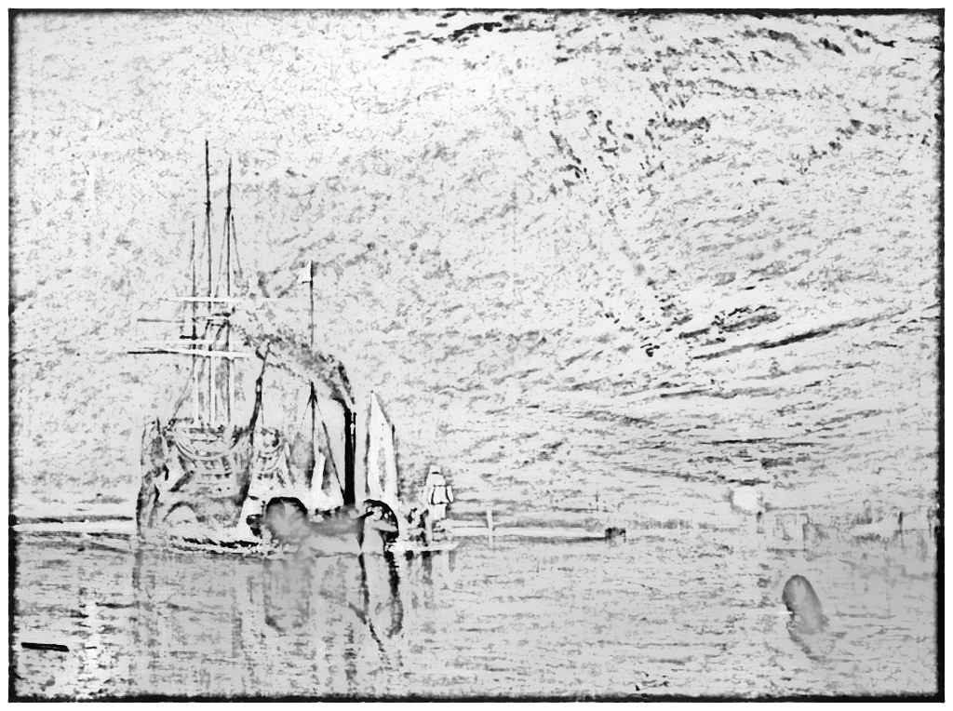
fleet= la flotte/ fought: prétérit de fight = se battre/decay = tomber en ruine/ tug = remorquer/ broken up = détruit/ pay tribute to = rendre hommage à/ shape = forme/fade away = disparaitre/squat = petit/wonder = se demander/ if= si/ young =jeune/ old= vieux/ above = au dessus

MME TUSSAUD’S
Si vous êtes en Angleterre, vous avez 1h30 pour visiter les 10 salles (rooms) ci-dessous et vous devez absolument voir le film en 4 D dans la section « marvel ». Si vous êtes en France, allez sur le lien https://www.madametussauds.com/london/en/ pour remplir le premier tableau ci-dessous, ne faites pas le second, vous poserez des questions à vos camarades à leur retour pour pouvoir le remplir.
Choisissez un personnage de cire dans chacune des 10 salles suivante et justifiez votre choix :
ROOMS | CHARACTERS | WHY ?
BOLLYWOOD | I chose Aishwarya Rai | because I think she is really beautiful.
FILM
YOU TUBE
SPORT
ROYALS
CULTURE
MUSIC
MARVEL
WORLD LEADER
PARTY

ROOMS? | CHARACTERS | Who are they? + date
 | WILLIAM SHAKESPEARE
 | CHARLES DICKENS
 | BENEDICT CUMBERBATH
 | WINSTON CHURCHILL
 | QUEEN VICTORIA
 | QUEEN ELIZABETH I
 | DONALD TRUMP

Because,since, as , for = parce que / like/love/detest/ can’t stand = ne pas supporter/ great = super, genial/ fantastic/powerful= puissant/ stupid/amazing =stupéfiant/awesome = impressionnat/cool/ ridiculous/pretty/ beautiful/ handsome = beau/ intelligent/athletic

ARSENAL STADIUM TOUR
- Classify these crests from the oldest to the most recent: 1 = the oldest and 4 =the most recent.

- What’s Arsenal Latin motto?: “V……………...Concordia Crescit”
In English this motto means “V……………… c……….. f….. H…………………”, what’s the French for this motto?………………………………………………………………………………………………………………………………………………
- In your opinion, explain in French what it implies for the manager and the team:
………………………………………………………………………………………………………………………………………………………………………………………………………………………………………………………………………………………………………………………………………………………………………………………………………………………………………………………………………………………………………………………………………………………………………………………………………………………………………………………………………………………………………………………………………………………………………………………………………………………………………………………………………………………………………………………………………………………………………………………………………………………………………………………………………………………………………………………………………………………………………………………………………………………………………………………………...
- Pensez-vous que cette devise (this motto) pourrait s’appliquer à votre classe et pourquoi ?
………………………………………………………………………………………………………………………………………………………………………………………………………………………………………………………………………………………………………………………………………………………………………………………………………………………………………………………………………………………………………………………………………………………………………………………………………………………………………………………………………………………………………………………………………………………………………………………………………………………………………………………………………………………………………………………………………………………………………………………………………………………………………………………………………………………………………………………………………………………………………………………………………………………………………………………………...

Crest = un blason/a motto = une devise/mean= signifier, vouloir dire/imply =impliquer, avoir pour conséquence/

ARSENAL STADIUM TOUR

FULL NAME
NICKNAME(S)
FOUNDED
GROUND
CAPACITY
OWNER
CHAIRMAN
MANAGER
LEAGUE

Pour les élèves en France : question à poser à vos camarades à leur retour.
- Did you like Arsenal Stadium Tour? Tell us why?
………………………………………………………………………………………………………………………………………………………………………………………………………………………………………………………………………………………………………………………………………………………………………………………………………………………………………………………………………………………………………………………………………………………………………………………………………………………………………………………………………………………………………………………………………………………………………………………………………………………………………………………………………………………………………………………………………………………………………………………………………………………………………………………………………………………………………………………………………………………………………………………………………………………………………………………………………………………………………………………………………………………………………………………………………………………………………………………………………………………………………………………………………………………………………………

HOW DID YOU LIKE YOUR TRIP TO LONDON? What did you like the most? What did you like the least?
……………………………………………………………………………………………………………………………………………………………………………………………………………………………………………………………………………………………………………………………………………………………………………………………………………………………………………………………………………………………………………………………………………………………………………………………………………………………………………………………………………………………………………………………………………………………………………………………………………………………………………………………………………………………………………………………………………………………………………………………………………………………………………………………………………………………………………………………………………………………………………………………………………………………………………………………………………………………………………………………………………………………………………………………………………………………………………………………………………………………………………………………………………………………………………………………………………………………………………………………………………………………………………………………………………………………………………………………………………………………………………………………………………………………………………………………………………………………………………………………………………………………………………………………………………………………………………………………………………………………………………………………………………………………………………………………………………………………………………………………………………………………………………………………………………………………………………………………………………………………………………………………………………………………………………………………………………………………………………………………………………………………………………………………………………………………………………………………………………………………………………………………………………………………………………………………………………………………………………………………………………………………………………………………………………………………………………………………………………………………………………………………………………………………………………………………………………………………………………………………………………………………………………………………………………………………………………………………………………………………………………………………………………………………………………………………………………………………………………………………………………………………………………………………………………………………………………………………………………………………………………………………………………………………………………………………………………………………………………………………………………………………………………………………………………………………………………………………………………………………………………………………………………………………………………………………………………………………………………………………………………………………………………………………………………………………………………………………………………………………………………………………………………………………………………………………………………………………………………………………………………………………………………………………………………………………………………………………………………………………………………………………………………………………………………………………………………………………………………………………………………………………………………………………………………………………………………………………………………………………………………………………………………………………………………………………………………………………………………………………………………………………………………….………………………………………………………………………………………………………………………………………………………………………………………………………………………………………………………………………………………………………………………………………………………………………………………………………………………………………………………………………

WE HOPE YOU HAD A NICE TIME AND LEARNT A LOT FROM THIS EXPERIENCE!

